**Lab 9: Implementation of Dynamic interior/ Exterior Routing (RIP, OSPF, BGP)**

**Theory**

**Dynamic Interior/Exterior Routing**

**Interior Routing:** Dynamic interior routing involves using routing protocols within a single autonomous system (AS), which is a collection of IP networks and routers managed by one organization. Interior Gateway Protocols (IGPs) automatically update routing tables when there are changes in the network topology, simplifying network management, especially in large systems. These protocols ensure that data packets find the most efficient path within the AS.

Common Interior Gateway Protocols include:

1. **RIP (Routing Information Protocol)**
2. **OSPF (Open Shortest Path First)**
3. **EIGRP (Enhanced Interior Gateway Routing Protocol)**

**Exterior Routing:** Dynamic exterior routing manages routing between different autonomous systems (AS), typically across the internet. Exterior Gateway Protocols (EGPs) enable organizations, ISPs, or large networks to exchange routing information. The most widely used EGP is the Border Gateway Protocol (BGP), which ensures data can efficiently traverse the internet by selecting the best path between ASes, considering network policies, attributes, and stability. Unlike interior protocols, BGP focuses on scalability, security, and policy-based routing to manage inter-AS traffic.

**Key Routing Protocols**

**RIP (Routing Information Protocol)**:  
A **distance-vector routing protocol**determines the best route using hop count as the metric. With a maximum hop limit of 15, it is suitable for smaller networks. However, its slow convergence and limited scalability make it less ideal for larger, more complex networks.

**OSPF (Open Shortest Path First)**:  
A **link-state routing protocol** that uses the Dijkstra algorithm to calculate the shortest path. **OSPF** is highly scalable, making it suitable for large networks. It supports features like route summarization and variable-length subnet masks (VLSMs). However, it requires more complex configuration compared to RIP.

**BGP (Border Gateway Protocol)**:  
A **path-vector protocol** used for routing between autonomous systems, primarily on the internet. **BGP** is essential for policy-based routing and traffic control between ISPs and large networks. While highly scalable, BGP is complex to configure and slower to converge compared to interior protocols like OSPF.

**Network Diagram**

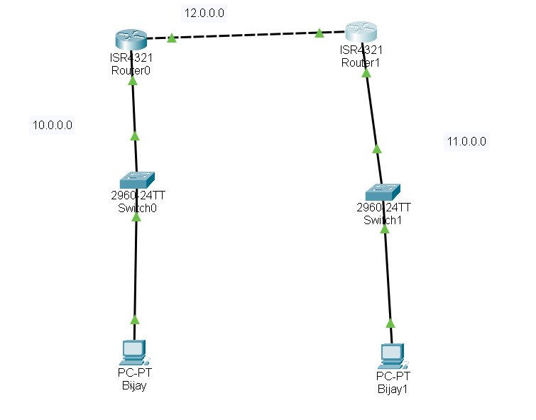

*Fig:Network Diagram*

**Configuring Network**

**Configure network for PCs and Routers**

**Steps:**

1) Configure the IP addresses of PCs connected to the each network.

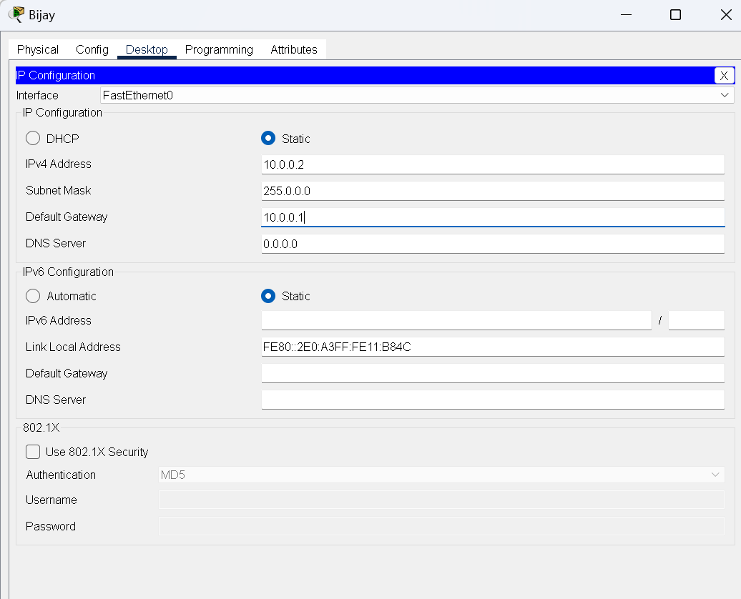

*Fig:IP configuration*

2) Configure the Gigabit Ethernet interfaces of the router to enable communication between different networks.

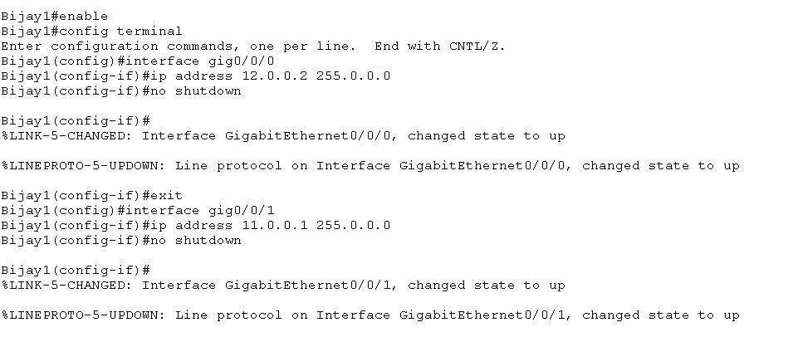

*Fig: Gigabit Ethernet configuration*

3) Repeat same for other PC’s and router as well.

**Implementation & Need for Dynamic Routing**

**Implementation**

### Dynamic routing protocols like ****RIP****, ****OSPF****, and ****BGP**** enable routers to automatically exchange and update routing information in response to network changes. Configuring routers with these protocols ensures that routing tables are dynamically updated without manual intervention.

### Network Configuration: **Device Setup**, Assign IP addresses to routers and PCs.

### ****Dynamic Routing Activation:**** Configure each router to use ****RIP****, ****OSPF****, or ****BGP**** based on the network’s size and complexity. This allows routers to automatically share and update routing information.

### ****Testing****: Use tools like ping to validate connectivity across routers and confirm proper routing.

### Importance of Dynamic Routing:

1. **Automatic Route Updates:** Dynamic routing automatically updates routing tables in response to network changes, such as link failures or new device additions, maintaining continuous connectivity without manual reconfiguration.
2. **Scalability:** In large or evolving networks, managing static routes becomes inefficient. Dynamic routing protocols handle growth seamlessly, ensuring efficient traffic routing as the network expands.
3. **Efficient Path Selection:** Dynamic routing protocols monitor network conditions and select the most efficient path for data transmission, optimizing performance and reducing delays.

**Dynamic Routing Configuration**

**Using RIP Command**

**Network Diagram**



*Fig:Network Diagram*

**Connection Testing Before Dynamic Routing Configuration using RIP command**

**Steps:**

1.Pinging PC *PC(Bijay1(10.0.0.2))*from PC(*Bijay(10.0.0.1*)) to verify connection if exists. .

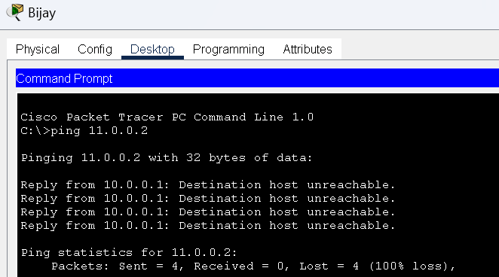

*Fig:Connectivity test from PC(Sangit1(10.0.0.1)) to PC(Sangit2(10.0.0.2))*

Here we can see there is not any connection in the network.So to establish connection in the network ,we need to dynamically configure the router through CLI using RIP command.

**Code For Dynamic Routing Configuration Using RIP Command**

**For Router 0:**

Router0> enable

Router0# configure terminal

Router0(config)# router rip

Router0(config-router)# version 2

Router0(config-router)# network 12.0.0.0

Router0(config-router)# network 11.0.0.0

Router0(config-router)# exit

**For Router 1:**

Router1> enable

Router1# configure terminal

Router1(config)# router rip

Router1(config-router)# version 2

Router1(config-router)# network 10.0.0.0

Router1(config-router)# network 12.0.0.0

Router1(config-router)# exit

**Steps For Dynamic Routing Configuration Using RIP Command**

**1. Access Router.**

**2. Enable RIP on Router.**

3. Specify RIP version 2 (for more efficiency and subnet support).

4. Advertise the networks connected to Router1 (LAN and WAN).

5. Exit RIP configuration.

6. Repeat same steps for another Router.

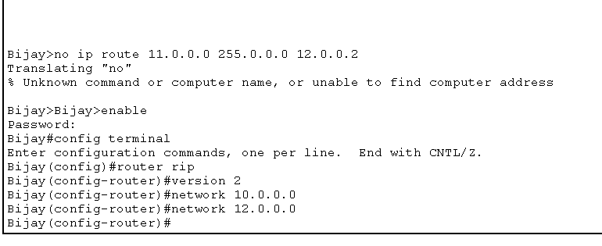

*Fig:Router configuration on router(Sangit1) using RIP command.*

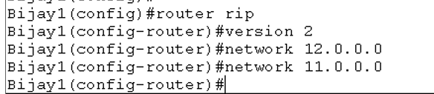

*Fig:Router configuration router(Sangit2) using RIP command.*

**Testing and Validation**

To test whether the network is working, you can ping other devices on the network from each PC.

**Steps:**

1. Ping PC(Bijay1(10.0.0.1)) from PC(Bijay2(11.0.0.2)) .

2. If the ping is successful, you should see replies from the other device.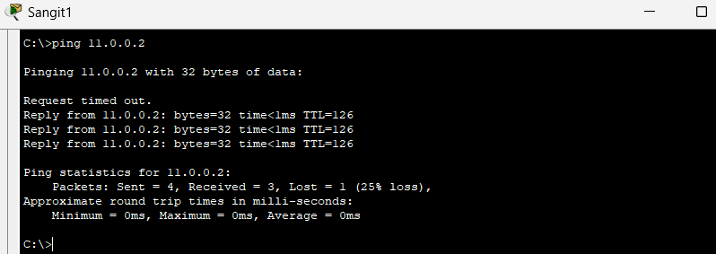

*Fig:Connectivity test from* PC(Bijay1(10.0.0.1)) *to* PC(Bijay2(11.0.0.2))

**Using OSPF Command**

**Network Diagram**

*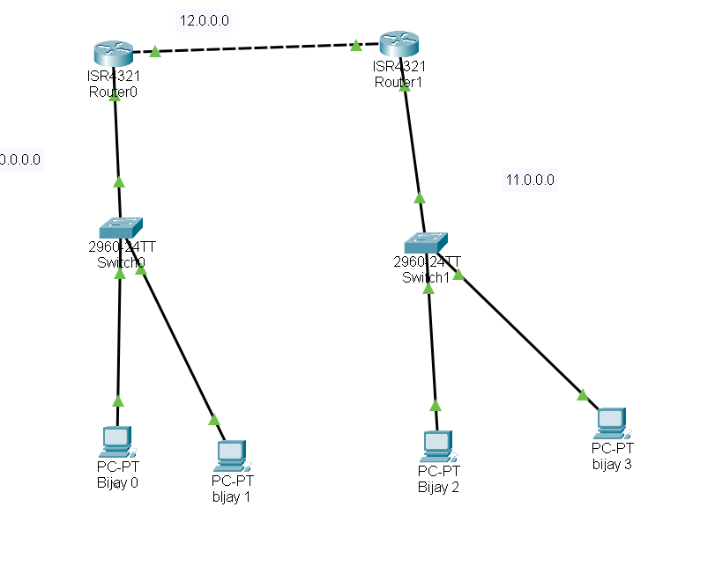Fig:Network Diagram*

**Connection Testing Before Dynamic Routing Configuration using OSPF command**

**Steps:**

1. Pinging PC(Bijay0(192.168.1.2)) from PC(Bijay2(192.168.2.2)) to verify connection if exists. .

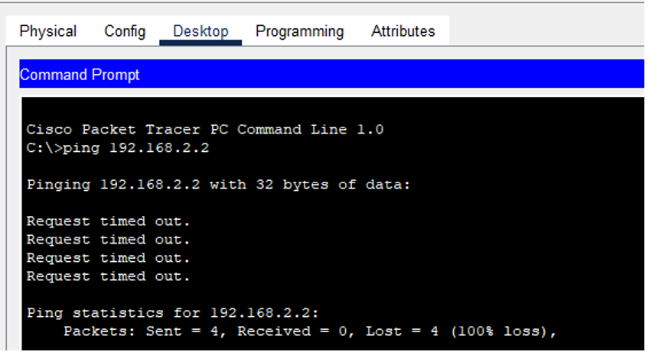

*Fig: Connectivity test from* PC(Bijay2(192.168.2.2)) *to* PC(Bijay 0(192.168.1.2))

Here we can see there is not any connection in the network.So to establish connection in the network ,we need to dynamically configure the router through CLI using OSPF command.

**Code For Dynamic Routing Configuration Using OSPF Command**

**For Router 0:**

Router0> enable

Router0# configure terminal

Router0(config)# router ospf 1

Router0(config-router)# network 192.168.1.0 0.0.0.255 area 0

Router0(config-router)# network 192.168.2.0 0.0 0.255 area 0

Router0(config-router)# exit

**For Router 1:**

Router1> enable

Router1# configure terminal

Router1(config)# router ospf 2

Router1(config-router)# network 192.168.1.0 0.0.0.255 area 0

Router1(config-router)# network 192.168.3.0 0.0 0.255 area 0

Router1(config-router)# exit

**Steps For Dynamic Routing Configuration Using OSPF Command**

**1.Access Router.**

2.Start the OSPF process and assign it a process ID (use 1 in this case)

3.Assign a router ID (OSPF will choose automatically if omitted)

4.Specify the networks connected to Router1, and define the areas.

5.Exit OSPF configuration.

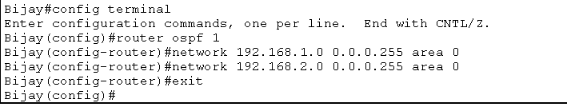

*Fig:Router configuration on router (Sangit1) using OSPF command.*

6.Repeat same steps for another Router.

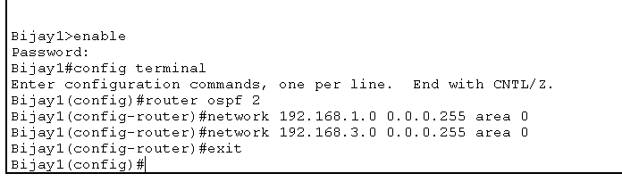

*Fig:Router configuration on router(Sangit2)using OSPF command.*

**Testing and Validation**

To test whether the network is working, you can ping other devices on the network from each PC.

**Steps:**

1. Ping PC(Bijay2(192.168.2.2)) from PC(Bijay 1(192.168.1.3)) .

2. If the ping is successful, you should see replies from the other device.

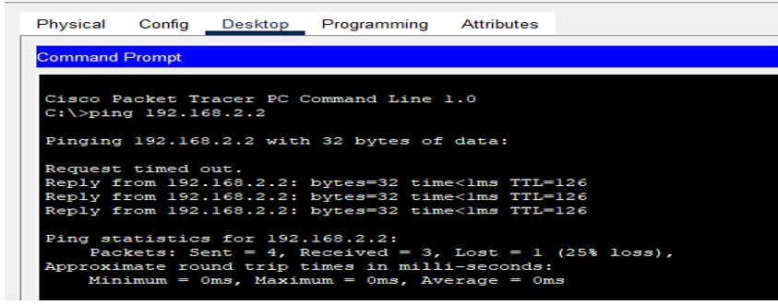

*Fig:Connectivity test from PC(Bijay 1(192.168.1.3)) to PC(Bijay2(192.168.2.2))*

**Using BGP Command**

**Network Diagram**

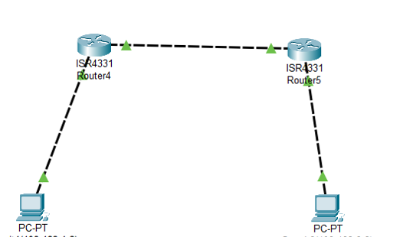

*Fig:Network Diagram*

**Connection Testing Before Dynamic Routing Configuration using BGP command**

**Steps:**

1.Pinging PC (Bijay2(192.168.3.2)) from PC (Bijay1(192.168.1.2)) to verify connection if exists. .

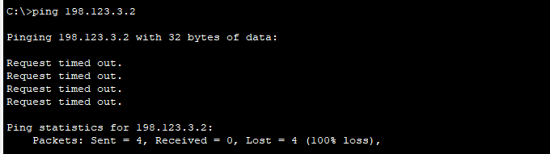

*Fig:Connectivity test from* PC (Bijay1(192.168.1.2)) *to* (Bijay2(192.168.3.2))

Here we can see there is not any connection in the network.So to establish connection in the network ,we need to dynamically configure the router through CLI using BGP command.

**Code For Dynamic Routing Configuration Using BGP Command**

**For Router 0:**

Router0> enable

Router0# configure terminal

Router0(config)# router bgp 100

Router0(config-router)# network 198.123.1.0

Router0(config-router)# network 198.123.2.0

Router0(config-router)# neighbor 198.123.2.2 remote-as 200

Router0(config-router)# neighbor 198.123.3.2 remote-as 200

Router0(config-router)# exit

**For Router 1:**

Router1> enable

Router1# configure terminal

Router1(config)# router bgp 65002

Router0(config-router)# network 198.123.2.0

Router0(config-router)# network 198.123.3.0

Router0(config-router)# neighbor 198.123.2.1 remote-as 200

Router0(config-router)# neighbor 198.123.1.2 remote-as 200

Router0(config-router)# exit

**Steps For Dynamic Routing Configuration Using BGP Command**

**1. Access Router.**

2. Start the BGP process and specify the AS number (65001)

3. Specify Router1 as a neighbor and provide its AS number (65002)

4. Advertise the LAN network behind Router1

5. Exit BGP configuration.

6. Repeat same steps for another Router.

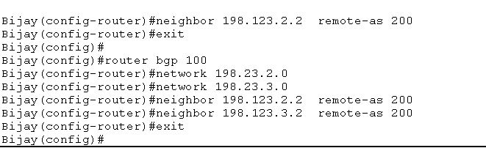

*Fig:Router configuration on router(Sangit1) using BGP command.*

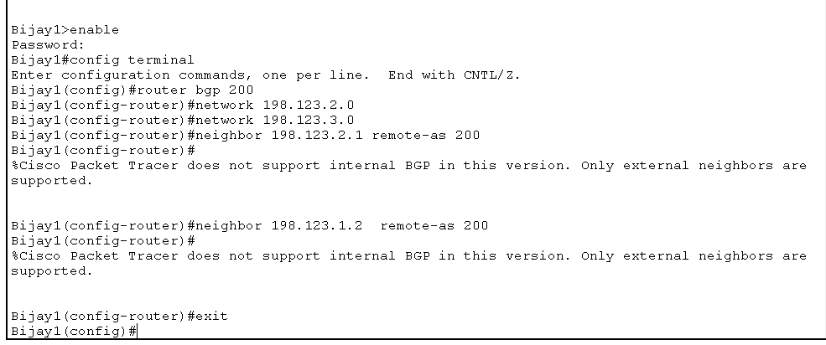

*Fig:Router configuration on router(St2) using BGP command.*

**Testing and Validation**

To test whether the network is working, you can ping other devices on the network from each PC.

**Steps:**

1. Ping PC(Bijay2(192.123.3.2)) from PC(Bijay1(192.123.1.2)) .

2. If the ping is successful, you should see replies from the other device.

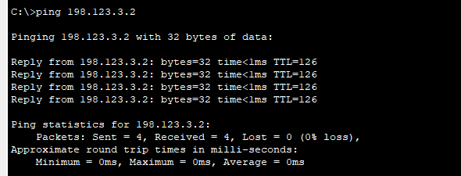

*Fig: Connectivity test from PC(sangit1(192.123.1.2)) to PC(sangit2(192.123.3.2))*

**Conclusion**  
In conclusion, we successfully implemented and demonstrated the functionality of three key dynamic routing protocols—**RIP**, **OSPF**, and **BGP**—across both interior and exterior routing scenarios. Each protocol effectively addressed different network needs based on size, complexity, and specific requirements. Through testing and verification, we observed how dynamic routing protocols automatically adapted to network changes, ensuring efficient and reliable data routing.